UNIT TEST FRAMEWORKS
Practical Assignment & Verification Report

Item | Details
Project Workspace | D:\Personal Projects\ROBOT
Frameworks | Python unittest and PyTest
Automation | Selenium with headless Chrome
Reporting | pytest-html
Evidence | Verified terminal runs, HTML report, project structure, source code and test data
Date | 26 September 2026

Purpose: This report documents the implemented unit-test framework syllabus using the actual project structure, source code, test data, terminal execution evidence and HTML reporting evidence supplied for the practical work.

Contents
1. Objective and Scope
2. Verified Environment
3. Project Structure
4. Python unittest
5. PyTest Fundamentals
6. PyTest Fixtures and conftest.py
7. Selenium + PyTest
8. Page Object Model (POM)
9. Assignment 7 — POM Restructure
10. Assignment 8 — Data-Driven Testing
11. Assignment 9 — PyTest HTML Reporting
12. Failure Screenshot Handling
13. Execution Evidence
14. Final Verification Summary
15. Conclusion
Evidence note: The screenshots in this report are the screenshots supplied during the practical verification. Where a current screenshot differs slightly in execution time from an earlier written verification note, the current screenshot is treated as the direct execution evidence.

1. Objective and Scope
The practical work covers Python unit-test frameworks and browser automation using PyTest and Selenium. The completed material includes the Python built-in unittest framework, PyTest basics, fixtures, shared fixtures through conftest.py, Selenium browser testing, HTML reporting, the Page Object Model (POM), data-driven testing with CSV input, and failure screenshot handling.
The supplied documentation describes the same project as a completed practical assignment and lists the verified components: unittest introduction, first test, class-level setup/teardown, assertions, test suites, PyTest basics, fixtures, Selenium integration, HTML reporting, POM, and Assignments 7–9.
Practical outcome: The project was executed from the terminal and the final PyTest suite generated an HTML report. The evidence supplied here shows the actual commands and results rather than simulated output.

2. Verified Environment
Component | Verified value
Operating environment | Windows 11
Python | 3.14.3
PyTest | 9.1.1
pytest-html | 4.2.0
Selenium | 4.49.0
Browser automation | Selenium Manager + headless Chrome
Project workspace | D:\Personal Projects\ROBOT

3. Project Structure
The following is a cleaned presentation of the project tree shown in the terminal. Generated cache directories such as __pycache__ and .pytest_cache are omitted from the conceptual tree because they are runtime artifacts.
D:\Personal Projects\ROBOT\
├── requirements.txt
├── documentation\
│ ├── 10_unittest_introduction.md
│ ├── 11_unittest_first_test.md
│ ├── 12_unittest_setup_teardown.md
│ ├── 13_unittest_assertions_and_test_suites.md
│ ├── 14_pytest_introduction.md
│ ├── 15_pytest_fixtures_and_conftest.md
│ ├── 16_pytest_selenium.md
│ ├── 17_pytest_html_reporting.md
│ ├── 18_page_object_model.md
│ ├── 19_assignment_7_pom.md
│ ├── 20_assignment_8_data_driven.md
│ ├── 21_assignment_9_pytest_html_reporting.md
│ └── 22_unit_test_framework_final_summary.md
├── pytest_project\
│ ├── config.py
│ ├── conftest.py
│ ├── pages\
│ │ ├── base_page.py
│ │ └── login_page.py
│ ├── reports\
│ │ ├── before_fail_demo.html
│ │ ├── final_report.html
│ │ └── report.html
│ ├── screenshots\
│ ├── tests\
│ │ ├── test_basic.py
│ │ ├── test_data_driven.py
│ │ ├── test_fixture_example.py
│ │ └── test_login.py
│ ├── test_data\
│ │ ├── login_data.csv
│ │ └── login_page.html
│ └── utilities\
│ └── csv_reader.py
└── unittest_project\
├── math_utils.py
├── test_suite.py
└── tests\
├── test_assertions.py
├── test_first_case.py
└── test_setup_teardown.py
The terminal tree supplied for the assignment shows the documentation folder, the unittest project, the PyTest project, POM page classes, reports, test data and utilities.

4. Python unittest

4.1 Introduction
Python's built-in unittest framework provides a structured way to write and execute test cases. Tests are commonly organized inside classes derived from unittest.TestCase, with assertion methods used to compare actual and expected behavior.
import unittest
def add_numbers(a, b):
return a + b
class TestMathFunctions(unittest.TestCase):
def test_add_numbers(self):
self.assertEqual(add_numbers(2, 3), 5)

4.2 First Test Case
The first practical test verifies add_numbers(2, 3) == 5. The supplied execution evidence shows one test executed successfully.
python -m unittest unittest_project/tests/test_first_case.py -v
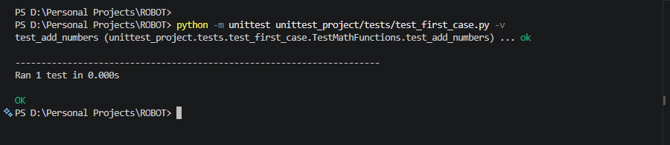
Figure 1 — unittest first test execution: 1 test ran and completed with OK.

4.3 Class-Level Setup and Teardown
setUpClass() executes once before all tests in a test class, while tearDownClass() executes once after all tests. This is useful when tests share a resource or state.
@classmethod
def setUpClass(cls):
cls.shared_value = 100
print("setUpClass() executed once before all tests in this class.")
@classmethod
def tearDownClass(cls):
print("tearDownClass() executed once after all tests in this class.")
cls.shared_value = None
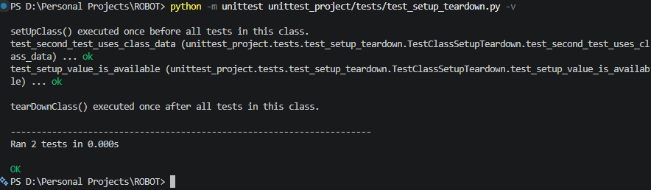
Figure 2 — setup/teardown execution: setup once, two tests, teardown once; 2 tests passed.

4.4 Assertions
The assertion example demonstrates equality, truth, false, membership and exception assertions using methods such as assertEqual, assertTrue, assertFalse, assertIn and assertRaises.
self.assertEqual(...)
self.assertTrue(...)
self.assertFalse(...)
self.assertIn(...)
self.assertRaises(...)
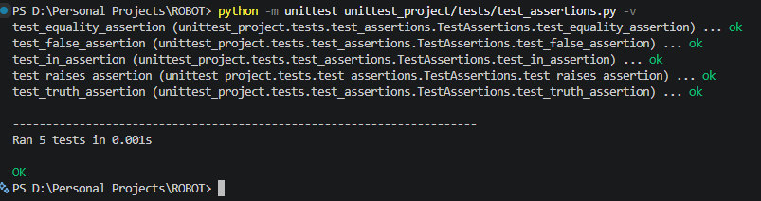
Figure 3 — unittest assertions execution: 5 assertion tests passed.

4.5 Test Suite and Complete unittest Run
The project also contains unittest_project/test_suite.py, which groups tests using unittest.TestSuite and runs them through a text runner.
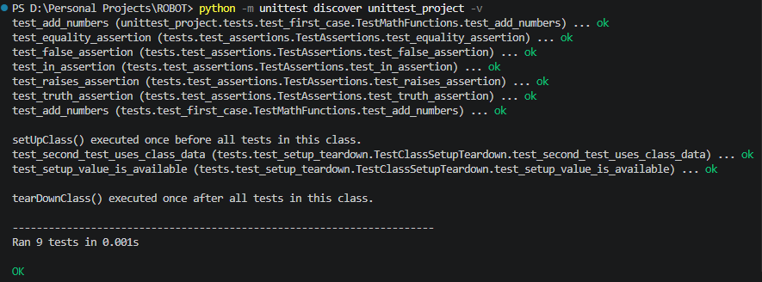
Figure 4 — complete unittest discovery run: 9 tests passed and overall result OK.
Current evidence: 9 tests were executed in the supplied complete discovery run. Earlier documentation recorded an 8-test discovery run; the current screenshot is the later direct execution evidence and therefore is the result presented in this report.

5. PyTest Fundamentals
PyTest provides a concise, function-oriented testing style. The practical examples use plain test functions and Python assert statements. PyTest discovers files such as test_*.py and *_test.py, and test functions beginning with test_.
def test_addition():
assert 2 + 3 == 5
def test_string_case():
assert "robot".upper() == "ROBOT"
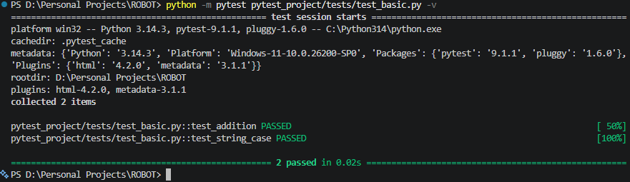
Figure 5 — PyTest basics: 2 tests passed.

6. PyTest Fixtures and conftest.py
A PyTest fixture is a reusable setup mechanism marked with @pytest.fixture. Fixtures can supply data or resources to test functions. Shared fixtures can be placed in conftest.py so tests can use them without directly importing the fixture.
import pytest
@pytest.fixture
def sample_data():
return {"name": "Robot", "score": 95}
def test_fixture_uses_data(sample_data):
assert sample_data["name"] == "Robot"
assert sample_data["score"] > 80
The project also uses a browser fixture in conftest.py so Selenium setup and teardown can be shared across browser tests.
@pytest.fixture
def browser():
options = Options()
options.add_argument("--headless=new")
options.add_argument("--disable-gpu")
options.add_argument("--window-size=1920,1080")
driver = webdriver.Chrome(options=options)
yield driver
driver.quit()
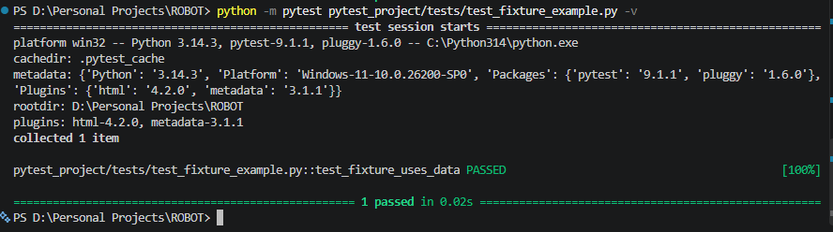
Figure 6 — PyTest fixture example: 1 test passed.

7. Selenium + PyTest
Selenium is used for browser automation. In this project, a PyTest browser fixture initializes headless Chrome, provides the driver to the test, and closes it after the test using yield. This keeps browser lifecycle management out of the individual test functions.
def test_valid_login(browser):
page = LoginPage(browser)
page.open_login_page(BASE_URL)
page.login("valid_user", "valid_password")
assert page.get_message() == "success"
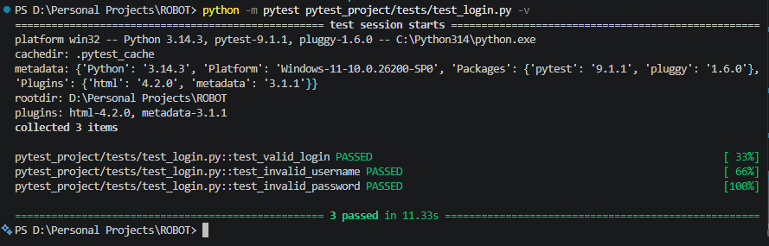
Figure 7 — Selenium + PyTest login suite: 3 browser tests passed.

8. Page Object Model (POM)
The Page Object Model separates Selenium interaction details from test assertions. A reusable BasePage holds common browser operations, while a page-specific class such as LoginPage contains locators and behavior for the login screen.

8.1 BasePage
from selenium.webdriver.common.by import By
from selenium.webdriver.support.ui import WebDriverWait
from selenium.webdriver.support import expected_conditions as EC
class BasePage:
def __init__(self, driver):
self.driver = driver
self.wait = WebDriverWait(driver, 10)
def open(self, url):
self.driver.get(url)
def find(self, locator):
return self.driver.find_element(*locator)
def click(self, locator):
self.wait.until(EC.element_to_be_clickable(locator)).click()
def enter_text(self, locator, value):
element = self.wait.until(
EC.visibility_of_element_located(locator)
)
element.clear()
element.send_keys(value)
def get_text(self, locator):
return self.wait.until(
EC.visibility_of_element_located(locator)
).text
def get_attribute(self, locator, attribute_name):
return self.wait.until(
EC.visibility_of_element_located(locator)
).get_attribute(attribute_name)
BasePage centralizes common Selenium operations such as opening pages, finding elements, clicking, entering text, reading text, and reading attributes.

8.2 LoginPage
from selenium.webdriver.common.by import By
from pytest_project.pages.base_page import BasePage
class LoginPage(BasePage):
USERNAME_INPUT = (By.ID, "username")
PASSWORD_INPUT = (By.ID, "password")
LOGIN_BUTTON = (By.ID, "login-btn")
MESSAGE = (By.ID, "message")
def open_login_page(self, url):
self.open(url)
def login(self, username, password):
self.enter_text(self.USERNAME_INPUT, username)
self.enter_text(self.PASSWORD_INPUT, password)
self.click(self.LOGIN_BUTTON)
def get_message(self):
return self.get_text(self.MESSAGE)
LoginPage inherits BasePage and exposes behavior-oriented methods. The locators are kept inside the page class instead of being repeated throughout tests.

8.3 Login Tests
from pytest_project.config import BASE_URL
from pytest_project.pages.login_page import LoginPage
def test_valid_login(browser):
page = LoginPage(browser)
page.open_login_page(BASE_URL)
page.login("valid_user", "valid_password")
assert page.get_message() == "success"
def test_invalid_username(browser):
page = LoginPage(browser)
page.open_login_page(BASE_URL)
page.login("invalid_user", "valid_password")
assert page.get_message() == "invalid_username"
def test_invalid_password(browser):
page = LoginPage(browser)
page.open_login_page(BASE_URL)
page.login("valid_user", "invalid_password")
assert page.get_message() == "invalid_password"

9. Assignment 7 — POM Restructure
Assignment 7 applies the Page Object Model to the Selenium tests. The structure separates common browser operations, page-specific behavior, tests, utilities, configuration and test data.
Layer | Project file | Responsibility
Base page | pages/base_page.py | Reusable Selenium operations and waits
Page object | pages/login_page.py | Login locators and login behavior
Tests | tests/test_login.py | Assertions for valid/invalid login behavior
Utilities | utilities/csv_reader.py | Read CSV rows for data-driven tests
Configuration | config.py | Reusable base URL and paths
Figure 8 — Assignment 7 execution evidence: 3 login tests passed.

10. Assignment 8 — Data-Driven Testing
Data-driven testing separates test inputs from the test logic. In this project, login cases are stored in a CSV file and passed to a parameterized PyTest test.

10.1 Test Data
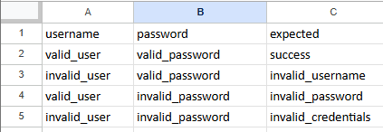
Figure 9 — login_data.csv containing the four login scenarios.

10.2 Parameterized Implementation
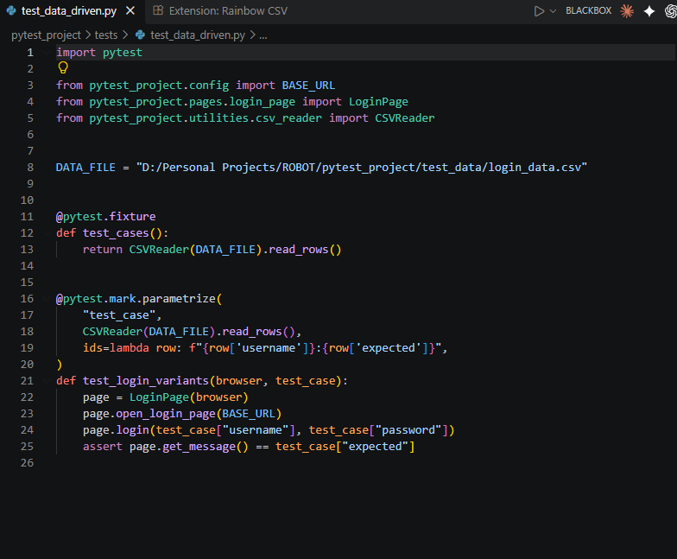
Figure 10 — test_data_driven.py using CSVReader, a fixture and pytest.mark.parametrize.
@pytest.mark.parametrize(
"test_case",
CSVReader(DATA_FILE).read_rows(),
ids=lambda row: f"{row['username']}:{row['expected']}",
)
def test_login_variants(browser, test_case):
page = LoginPage(browser)
page.open_login_page(BASE_URL)
page.login(test_case["username"], test_case["password"])
assert page.get_message() == test_case["expected"]

10.3 Execution Result
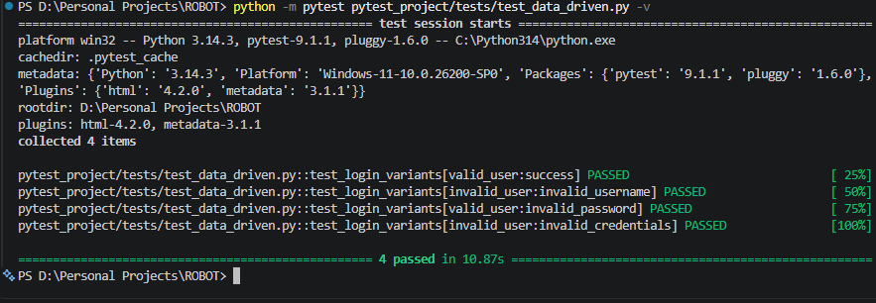
Figure 11 — data-driven test execution: all 4 parameterized cases passed.

11. Assignment 9 — PyTest HTML Reporting
PyTest HTML reporting provides a browser-readable record of test execution. The assignment combines the shared browser fixture, Selenium tests, PyTest execution and the pytest-html plugin.
python -m pytest pytest_project/tests -v --html=pytest_project/reports/final_report.html --self-contained-html
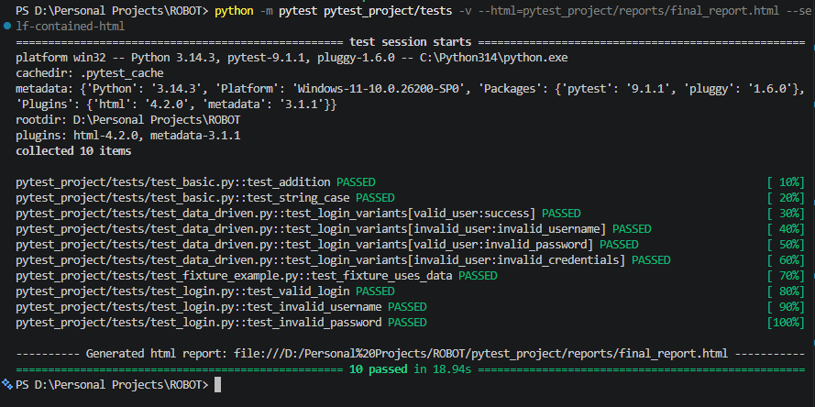
Figure 12 — final combined PyTest execution: 10 tests collected and 10 passed; final_report.html generated.
The supplied current terminal evidence reports 10 passed in 18.94s. Execution time can vary between runs; the current screenshot is the direct evidence used here.

11.1 HTML Report in Browser
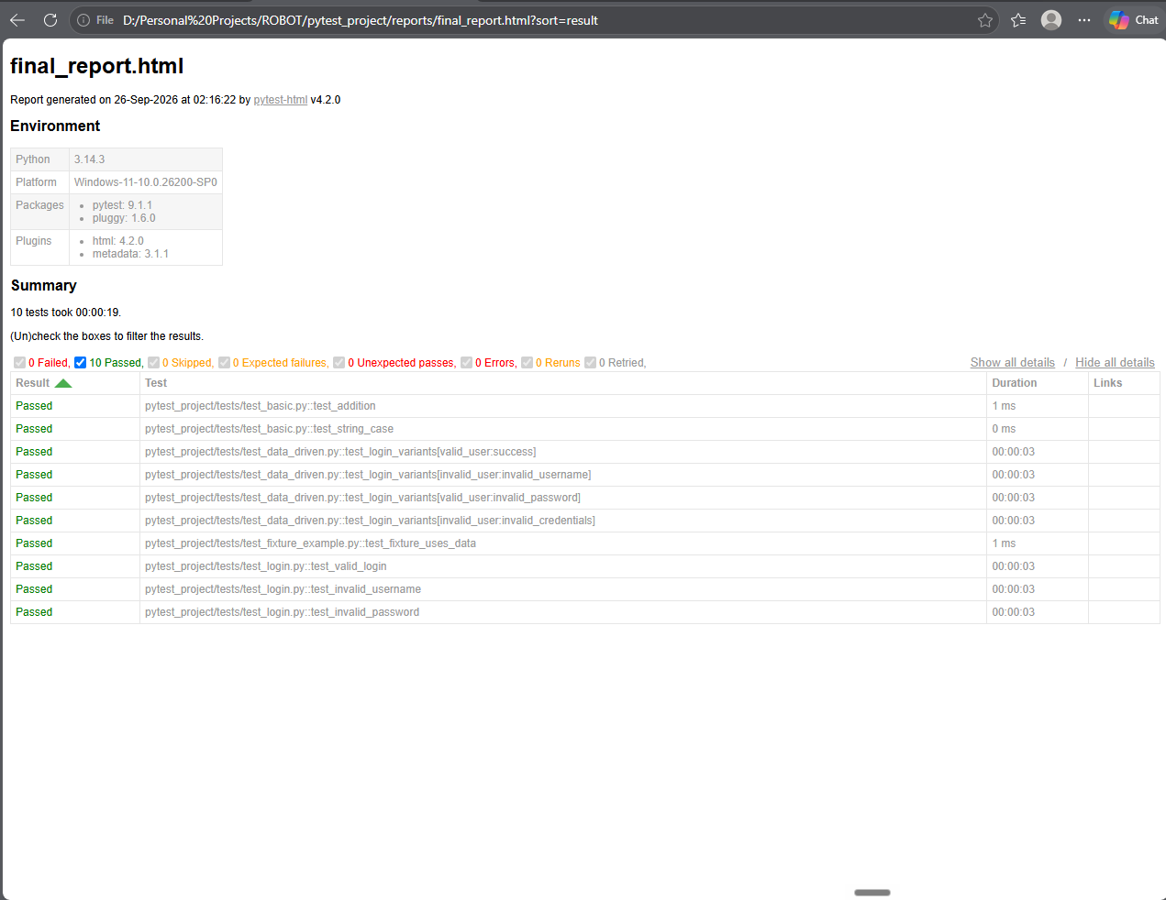
Figure 13 — final_report.html opened in the browser, showing 10 Passed and 0 Failed.

12. Failure Screenshot Handling
The project includes failure-screenshot handling in conftest.py. The practical documentation states that a PyTest hook saves a PNG screenshot when a test fails and places it in pytest_project/screenshots/. A temporary deliberate failure was executed separately to verify this behavior, then removed so the final suite remained passing.
python -m pytest pytest_project/tests/test_failure_demo.py -q --html=pytest_project/reports/failure_demo.html --self-contained-html
Recorded verification: the failure run saved a screenshot named test_deliberate_failure.png and returned 1 failed. The temporary failure-only test was then removed.
No fabricated failure screenshot is included in this report because the actual PNG was not supplied in the conversation. The behavior is documented from the verified project record instead.

13. Execution Evidence
Area | Evidence | Observed result
unittest first test | Terminal screenshot | 1 test; OK
unittest setup/teardown | Terminal screenshot | 2 tests; OK
unittest assertions | Terminal screenshot | 5 tests; OK
complete unittest discovery | Terminal screenshot | 9 tests; OK
PyTest basics | Terminal screenshot | 2 passed
PyTest fixture | Terminal screenshot | 1 passed
Selenium + PyTest | Terminal screenshot | 3 passed
Data-driven testing | Terminal screenshot | 4 passed
Final PyTest suite | Terminal screenshot | 10 passed
HTML report | Browser screenshot | 10 Passed; 0 Failed
CSV data | Editor/spreadsheet screenshot | 4 login scenarios
DDT implementation | VS Code screenshot | CSVReader + parameterization

13.1 Important Current Execution Values
Test group | Current supplied evidence
unittest first test | 1 passed / OK
unittest setup/teardown focused file | 2 passed / OK
unittest assertions | 5 passed / OK
complete unittest discovery | 9 passed / OK
PyTest basic | 2 passed
PyTest fixture | 1 passed
Selenium login | 3 passed
CSV data-driven | 4 passed
final combined PyTest | 10 passed; 0 failed

14. Final Verification Summary
The completed practical demonstrates the requested framework concepts through source code, organized project structure, test data and actual executions.
Component | Implemented | Verified
unittest introduction | Yes | Yes
First unittest test | Yes | Yes — 1 test
setUpClass / tearDownClass | Yes | Yes — focused tests and complete suite
unittest assertions | Yes | Yes — 5 tests
unittest TestSuite | Yes | Yes — included in project
PyTest basics | Yes | Yes — 2 tests
PyTest fixtures | Yes | Yes — 1 test
conftest.py browser fixture | Yes | Yes — used by Selenium tests
Selenium + PyTest | Yes | Yes — 3 tests
HTML reporting | Yes | Yes — final_report.html
Page Object Model | Yes | Yes — BasePage + LoginPage
Data-driven testing | Yes | Yes — 4 CSV cases
Failure screenshot support | Yes | Verified separately in project record

15. Conclusion
The Unit Test Framework practical assignment has been implemented and verified using a real Python project in D:\Personal Projects\ROBOT. The work demonstrates both the standard library's unittest approach and the more concise PyTest workflow.
The PyTest portion extends into reusable fixtures, Selenium browser automation, Page Object Model design, CSV-driven parameterization and HTML reporting. The supplied current evidence shows a final combined run of 10 passed tests and an HTML report displaying 10 Passed and 0 Failed.
The report intentionally distinguishes between the final passing suite and the separately executed controlled failure used to verify screenshot-on-failure behavior. This keeps the final result accurate while still documenting the failure-handling feature.
Overall practical status: COMPLETED AND VERIFIED.

End of Unit Test Frameworks Practical Assignment

